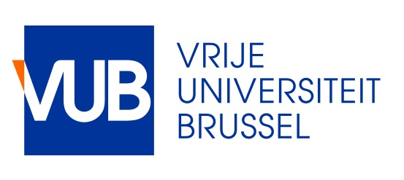
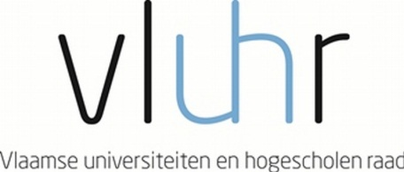

Master Mind Scholarships
Fellowship Programme for Excellent Students
Academic year 2018 – 2019

The Government of Flanders awards up to 40 scholarships to outstanding Master students. The programme aims to promote the internationalisation of the Flemish Higher Education, as stated in the Action Plan for Student Mobility, Brains on the Move (September 2013).

The Vrije Universiteit Brussel applies on behalf of the student.

General eligibility requirements

- The applicant has been admitted to take up an Initial Master degree programme at the Vrije Universiteit Brussel (VUB). (http://www.vub.ac.be/en/studying-at-the-vub/how-to-enroll) . A copy of the admission letter issued by the Education and Student Administration Office at the Vrije Universiteit Brussel should be enclosed with the application file for a Master Mind scholarship.
- The applicant should have a high standard of academic performance
  - The student has a Grade Point Average of 3.0 out of 4.0 (https://www.foreigncredits.com/resources/gpa-calculator/)
  - The student has a sufficient knowledge of the English language
    - An overall band score of minimum 7.0 on the IELTS test
    - A minimum total score of 100 on a TOEFL iBT test
    - A C1 level on the Certificate in Advanced English (CAE)
- All nationalities can apply. The previous degree obtained should be from a higher education institution located outside Flanders.
- Students who are already enrolled in a Flemish higher education institution cannot apply.

Modalities
- The program holds for all study areas. However some interuniversity Master programmes are excluded for a Master Mind scholarship.
- There are a number of scholarships reserved for students from certain countries: Japan (3), Mexico (3), USA (5) as these countries are priority countries for the Flemish government. If these numbers of scholarships are not taken up, they will be distributed among the other candidates.
- The incoming student is awarded a scholarship of maximum €8000,- per academic year.
- The duration of mobility is minimum 1 academic year and maximum the full duration of the master programme. If the student obtains less than 54 ECTS in the first year, then he/she loses the scholarship in the second year.
- The Vrije Universiteit Brussel submits the application, on behalf of the student.
- The Vrije Universiteit Brussel will ask the applicant for the lowest tuition fee rate. This tuition fee has to be paid per year of enrolment. For your information: for the academic year 2018-2019 this tuition fee equals 108,80 euro.

Application

The application for a Master Mind scholarship needs to be submitted to the Vrije Universiteit Brussel – International Relations and Mobility Office before the deadline of midnight on 15 March 2018 GMT+1 by sending the application file to Hilde.De.Haseleer@vub.be

Timing
- Deadline for applying for a Master Mind scholarship: 15 March 2018.
- As the Vrije Universiteit Brussel can only nominate 20 students for a scholarship, an internal selection will be held in case the number of application files received exceeds 20 files.
- Nominations of students by the Vrije Universiteit Brussel to the Flemish Department of Education and Training: 20 April 2018
- Upload of the documents by the nominated students: 30 April 2018
- Selection: May 2018 (A Flemish selection committee, in cooperation with the Flemish Department of Education and Training, awards the scholarships)
- Announcement of the selection results by the Flemish Department of Education and Training: June 2018
- Start of mobility: September 2018, for the academic year 2018-2019

Should you have questions about the scholarship programme, you can contact Hilde.De.Haseleer@vub.be

